Hall Ticket | 0425046036
Of Name the Student | SAMADHI HARSHITHA
Learning Track | DATA ANALYTIC WITH TABLEAU

Assignment
Area Chart:
- First, I took Order Date and dropped it in the column box.
- Then I right click year (Order Date) in the columns.
- I click on month to see monthly data.
- Then I dragged Quantity and put in the side row box.
- To add color, I took ship mode dragged it color in the marks box.
- In the marks box, I clicked to see chart options.
- Select the area chart in chart type.

OUTPUT:
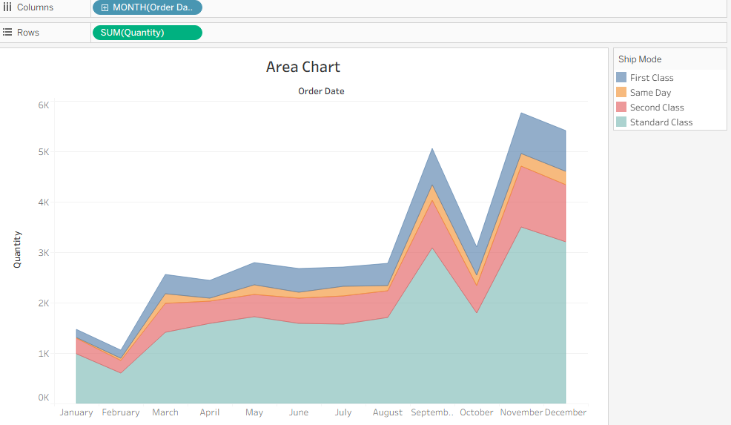

Bar Chart:
- First, I dragged sales and dropped it in the Rows box.
- In marks, I changed the chart type to bar.
- I dragged ship mode to color for different segments.
- Then I added region to rows to compare my region.
- I filtered region and selected only west remaining uncheck.
- Click ok.
OUTPUT:
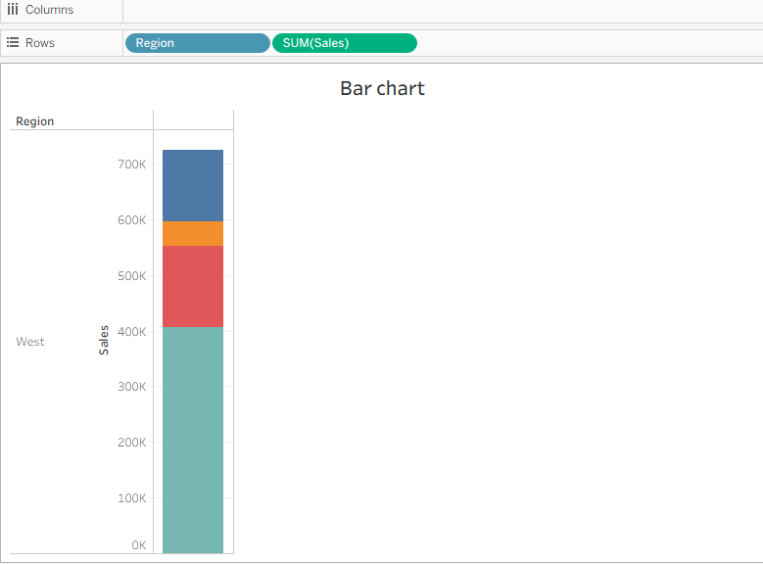

Box plot:
- First, I dragged segment to the columns shelf.
- Then I dragged discount on the rows shelf.
- I right clicked Discount on rows and hovered on measure.
- From there, I changed the aggregation to average.
- Next, I added region to columns shelf also.
- Region got placed on the right side of segment
- I clicked show me form the toolbar at the top.
- Then I selected box and whisker plot from show me.
- I moved region next to segment in columns for better view.
- I went to analysis menu and unchecked aggregate measures.
- Finally, I clicked swap rows and columns button to adjust layout

Output:
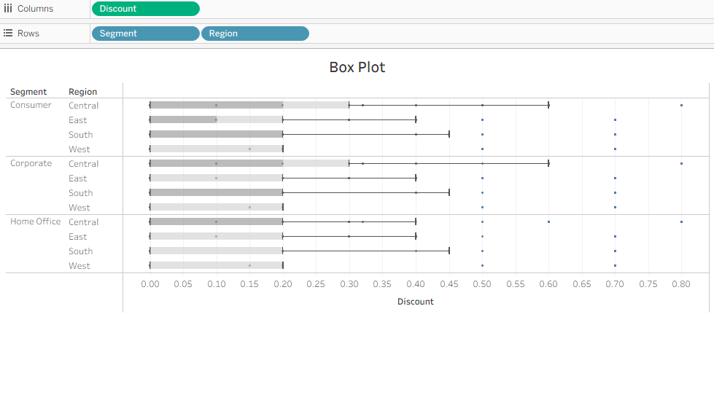Gantt chart:
- I dragged order date to columns shelf.
- I clicked the dropdown on YEAR (Oder date) and changed it to week numbers.
- Then I put sub-category in rows shelf.
- I added ship mode also in rows.
- In marks card, I changed chart type to Gantt bar.
- For shipping delay, I made a calculated filed named OrderUntilShip.
- Formula used: DATEDIFF (‘day’, [order date], [ship date]).
- I dragged OrderUntilShip to size.

- I right-clicked SUM(OrderuntilShip) and changed measure to average.
- Finally, I dragged ship mode to color for different colours.

Output:
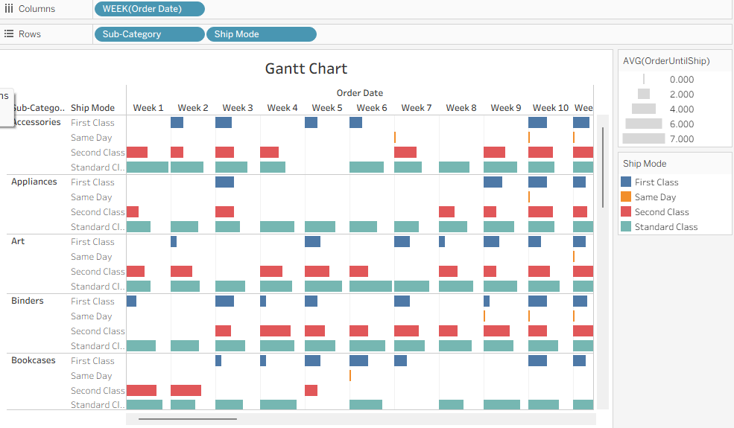

Heat Map:
- I dragged segment to the columns shelf. It shows consumer, corporate, home office.
- Then I put Region in the Rows shelf.
- Next to Region. I added sub-category also in Rows.
- I dragged profit to color in marks card.
- Now blue boxes = high profit, profit, orange boxes = loss
- I clicked color in marks and set Border to Medium Gray for clear boxes.
- Then I clicked the profit color legend selected Edit colours.
- I chose Red- Black diverging palette and ticked use full color Range.
- After Apply black= profit, red=loss.
- Initially, I dragged sales to size in marks card.
- Now bigger boxes= high sales, smaller boxes= low sales.

Output:
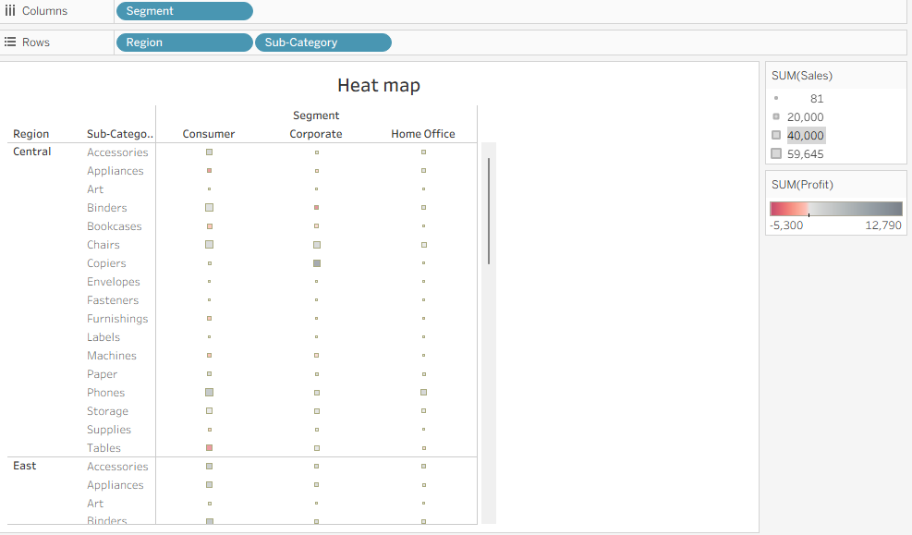

Histogram:

1. I dragged Quantity from Measures to Columns shelf.
2. I clicked Show Me and selected Histogram.
3. Tableau created Quantity (bin) on Columns and CNT(Quantity) on Rows.
4. X-Axis shows Quantity Bins; Y-Axis shows Count of Orders.
5. I dragged Segment to Colour in Marks card to see Consumer, Corporate, Home Office.
6. I held Ctrl and dragged CNT(Quantity) to Label.
7. I right-clicked CNT(Quantity) on Marks card and selected Quick Table Calculation → Percent of Total.
8. Key Insight: Most orders have quantity 2 or 3. Consumer segment has the highest orders.
Output:
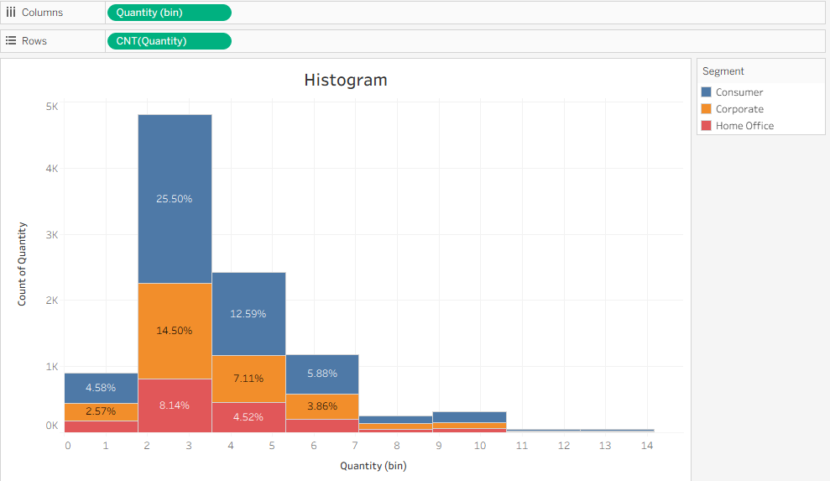

Line chart:
- I dragged Ship Date to Columns. Tableau showed years.
- I dragged Sales to Rows. A line chart came up.
- I dragged Profit to Rows next to Sales. It made two separate axes.
- I dragged Profit and dropped it on the Sales Axis to combine them. Now both use one axis.
- I clicked the dropdown on YEAR(Ship Date) and changed it to Month. Now it shows monthly trend for all years.
- Key Insight: Sales and Profit go up near year-end. This pattern happens every year. It is called Seasonality.
- I went to the Analytics Pane and dragged Forecast to the chart. Tableau showed the future trend.

Output:
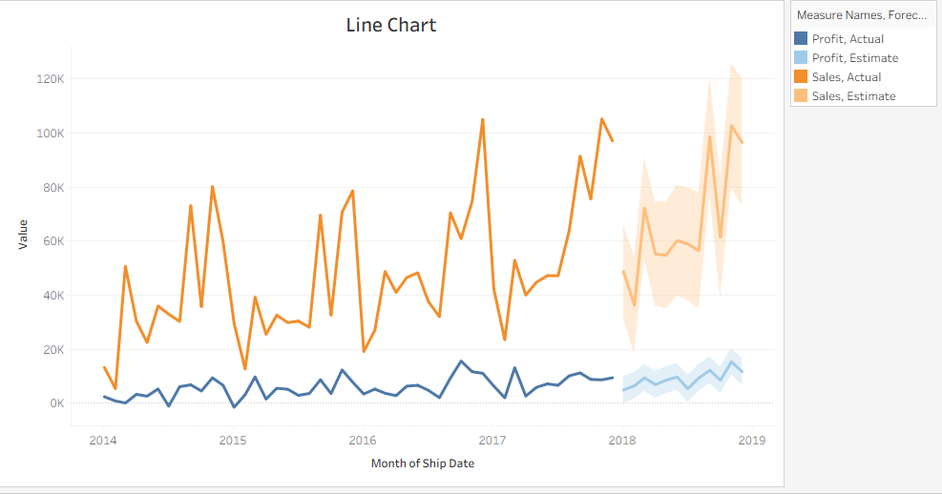

Bubble chart:
- I dragged Category from Dimensions to Columns. I saw Furniture, Office Supplies, and Technology.
- I dragged Sales from Measures to Rows. Tableau made a bar chart first.
- I clicked Show Me and selected Packed Bubbles. Now I got big and small bubbles for each category. Bubble size shows Sales.
- I dragged Region to Detail in the Marks card. Each category split into East, West, Central, and South bubbles.
- I dragged Profit to Colour. Dark blue bubbles mean high profit. Light blue means low profit. Orange/Red means loss.
- I dragged Region to Label. Now each bubble shows the region name.
- Key Insight: Technology has the biggest bubbles, so highest sales. Some bubbles are red, which means loss in that region and category.

Output:
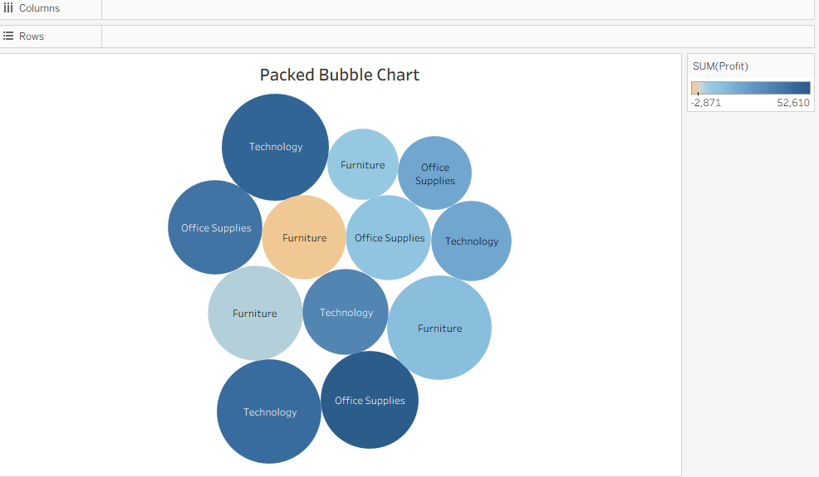

Pie chart:
- I dragged Profit from Measures to Columns.
- I dragged Category from Dimensions to Rows. Tableau first showed a bar chart.
- I clicked Show Me and selected Pie Chart. It changed to a pie automatically.
- Tableau put Profit on Angle and Size, and Category on Colour. So, each slice is a category.
- I made the pie bigger by clicking Fit → Entire View or by increasing Size in the Marks card.
- I dragged Category to Label so each slice shows Furniture, Office Supplies, and Technology.
- Key Insight: The biggest slice shows which category has the highest profit. It helps compare profit share easily.

Output:
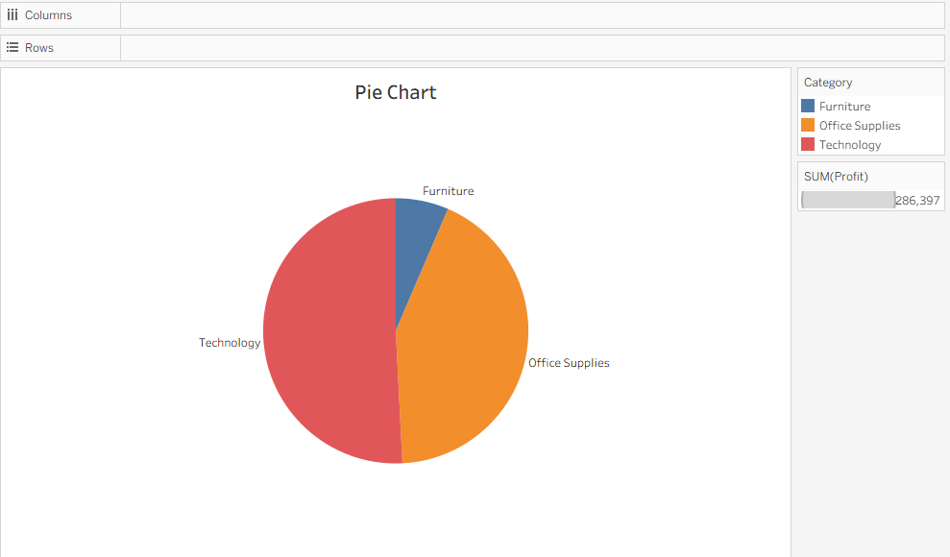

Scatter plot:
- I put Sales on Columns.
- I put Profit on Rows. A scatter plot appeared.
- I added Category to Colour. Dots split by Furniture, Office Supplies, Technology.
- I added Region to Detail. More dots came for Central, East, South, West.
- I dragged Trend Line from Analytics Pane and used Linear.
- Key Insight: Line going up means more sales = more profit. Dots below line = loss.

Output:
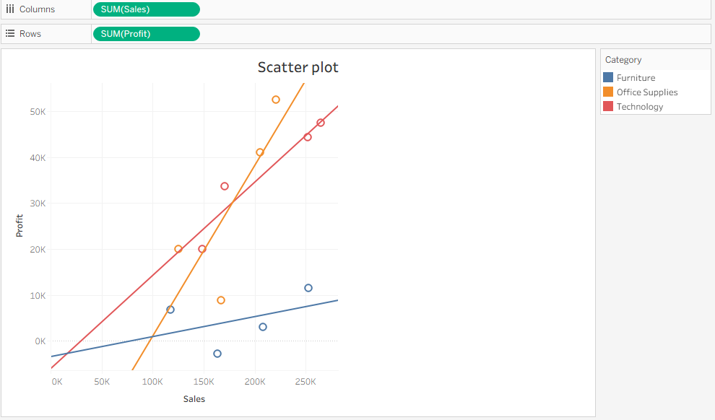

Text Table with Percentage:
- I put Order Date on Columns. It showed years.
- I put Sub-Category on Rows. A table came up.
- I put Sales on Text. Now cells show sales numbers.
- I put Region on Rows before Sub-Category. Table split by region → Sub-Category.
- I right-clicked SUM(Sales) → Add Table Calculation → Percent of Total.
- I set Compute Using to Pane (Down) and clicked OK. Numbers became %.
- Key Insight: This shows which region and sub-category got what % of sales each year.

Output:
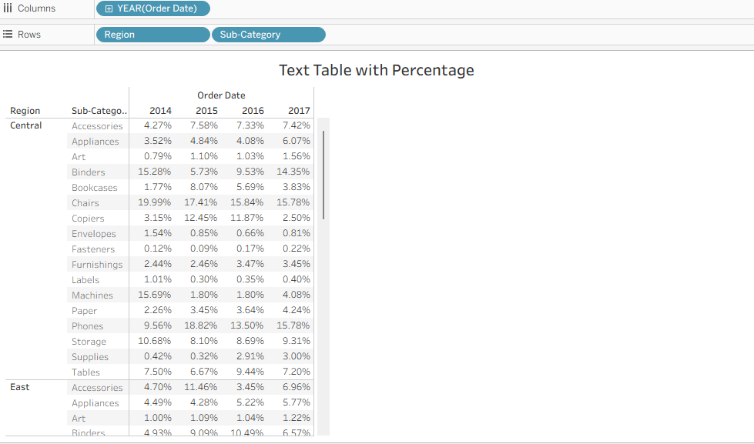

Tree map:
- I put Sub-Category on Columns. I saw sub-category names.
- I put Sales on Rows. Tableau first made a bar chart.
- I clicked Show Me and selected Tree map. Now it changed to rectangles.
- In tree map, big rectangle = high sales. Small rectangle = low sales.
- I dragged Ship Mode to Colour. Now rectangles got different colours for First Class, Second Class, Standard Class, Same Day.
- If I want profit, I remove Ship Mode and drag Profit to Colour instead. Then dark colour = high profit, light colour = low profit. Key Insight: Biggest box shows which sub-category has highest sales. Colour shows ship mode or profit.

Output:
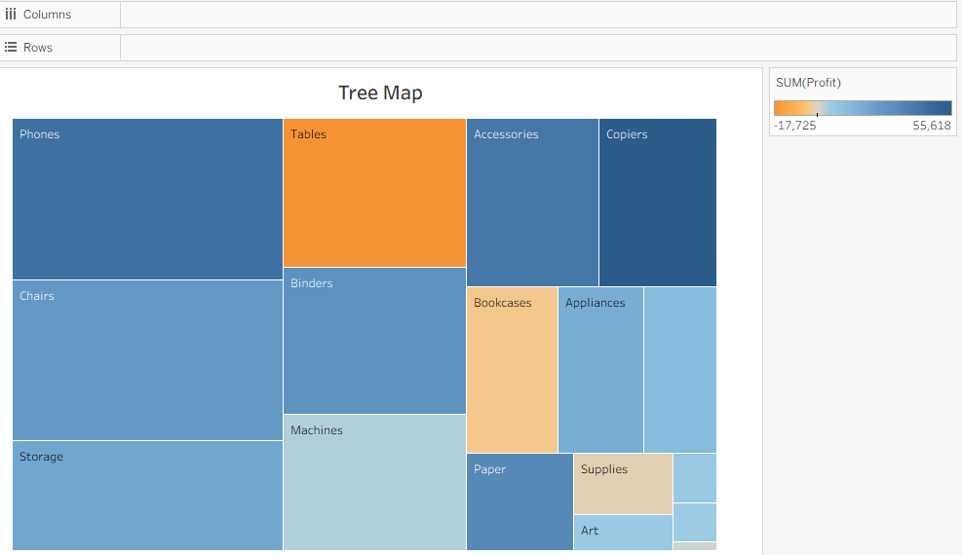

Donut chart:
- I went to Analysis and clicked Create Calculated Field. I named it Zero and typed 0. Then clicked OK.
- I dragged Zero to Rows. It made a blank axis.
- In Marks card I changed Automatic to Pie. I clicked Fit → Entire View. A big circle came.
- I increased the Size slider to make the pie bigger.
- I dragged Zero to Rows again, next to the first one. Now I got two circles.
- I right-clicked the second SUM(Zero) and clicked Dual Axis. Both circles overlapped.
- I clicked the second SUM(Zero) Marks card. I made Size smaller and set Colour to White. This made the donut hole.
- I clicked the first SUM(Zero) Marks card. I dragged Region to Colour. Each region got a different colour.
- I dragged Region to Label, Sales to Label, and Sales to Angle. Now slices show region and sales.
- I clicked the second SUM(Zero) Marks card. I dragged Sales to Label. I edited Label text and typed Total Sales. Now the centre shows total sales.
- Key Insight: Donut chart shows sales share by region. The hole in center shows total sales. Looks cleaner than pie chart.
Output: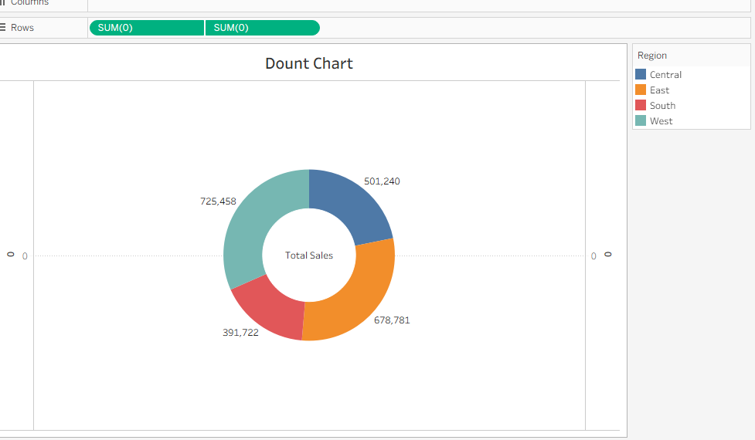

Map chart:
- I dragged State to the workspace. Tableau made a map automatically.
- I dragged Sales to Colour in Marks card. Now states got different colours based on sales. Dark = high sales, light = low sales.
- In Marks card I changed Automatic to Filled Map. Now full states are coloured, not just dots.
- I clicked Colour → Edit Coors and picked a Purple palette. Then clicked OK.
- I dragged State to Label and Sales to Label. Now each state shows its name and sales value.
- I dragged Region to Filters and selected All regions. Now I can filter by region.
- I dragged Profit to Tooltip. When I hover on a state, it shows sales and profit.
- I went to Map → Map Layers. I set Background style to Outdoors and Washout to 70% to make it clean.
- Key Insight: Map shows which states have highest and lowest sales. Easy to see region-wise performance.
Output:
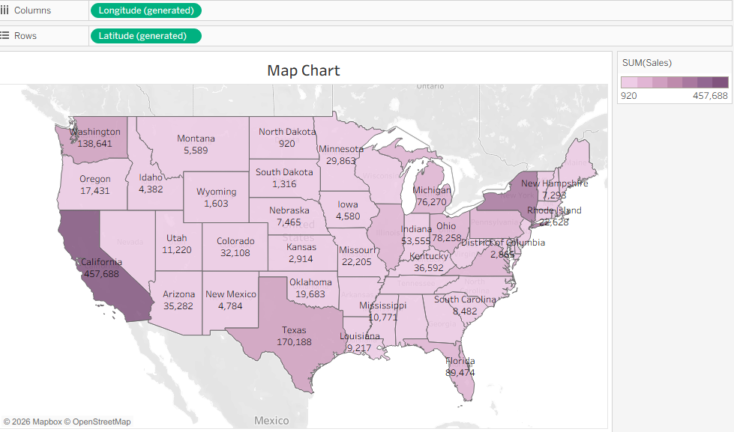

DASHBOARDS:

Dashboard-01:

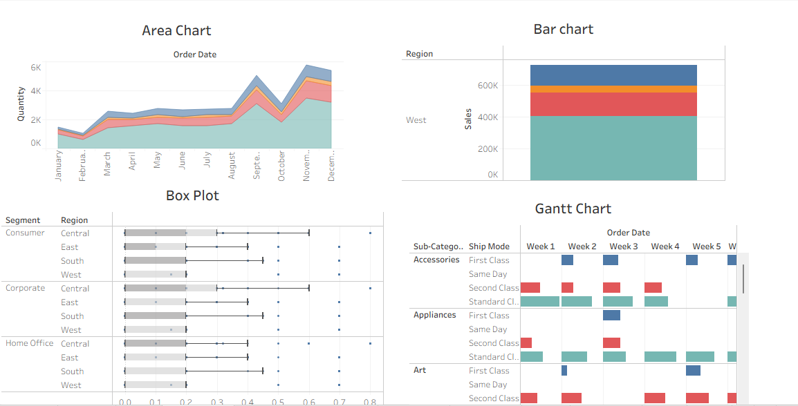

Dashboards-02:

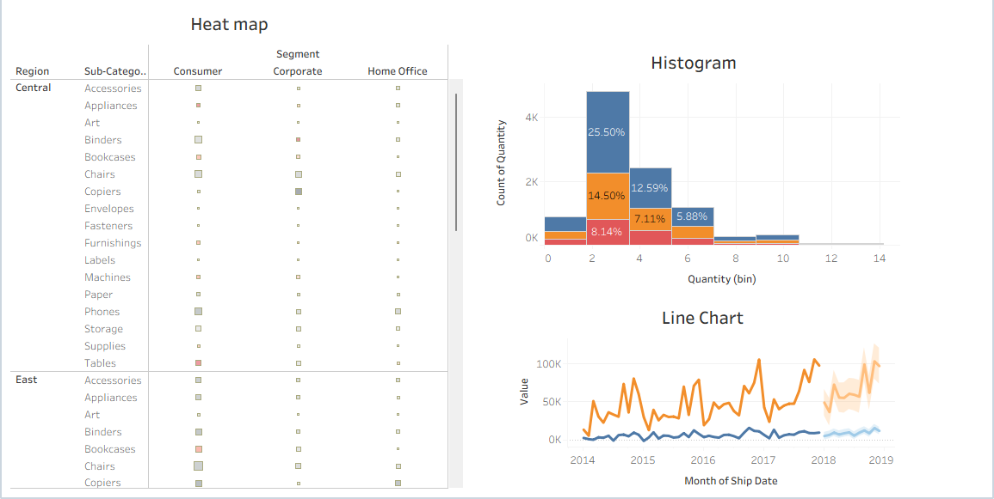
Dashboard-03:

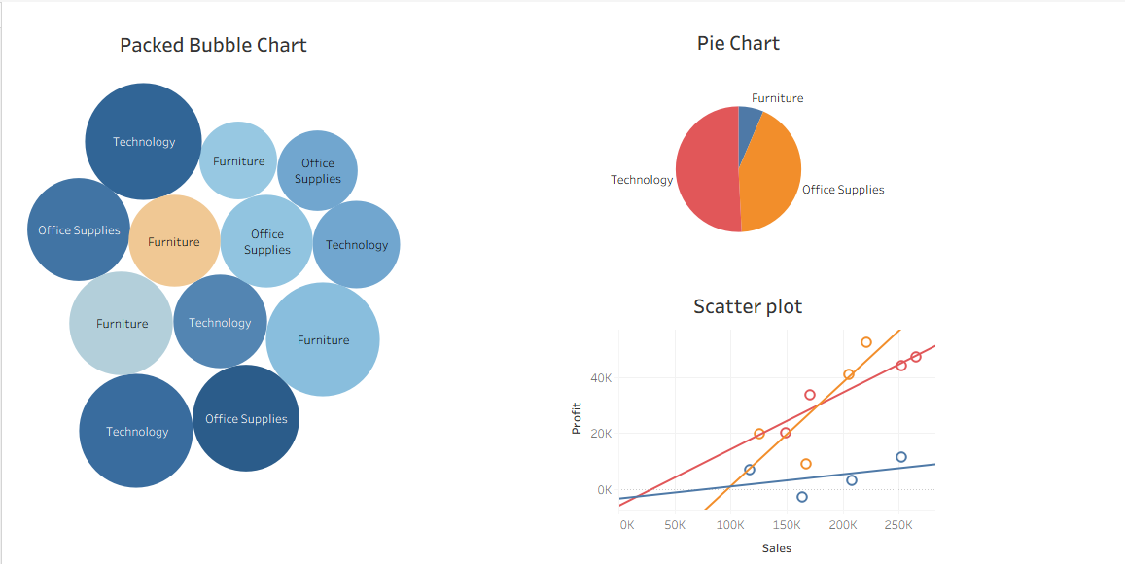

Dashboard-04:

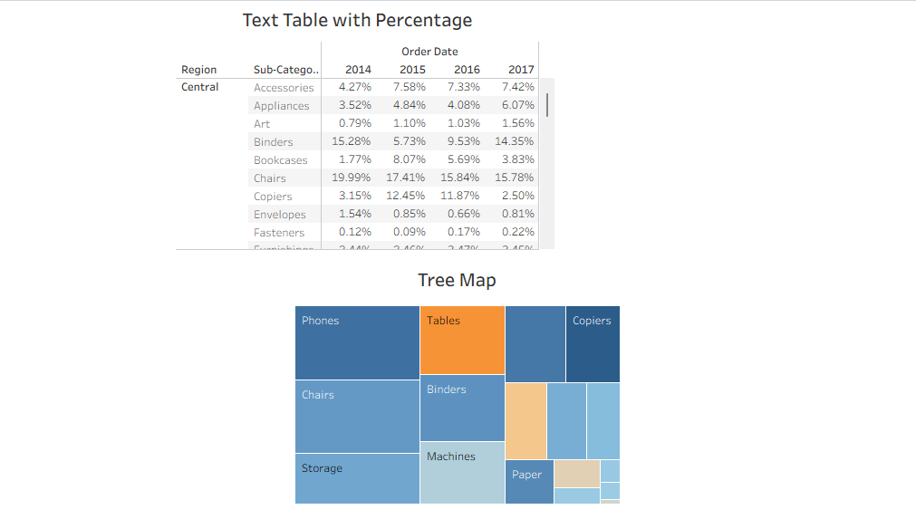

Dashboard-05:

